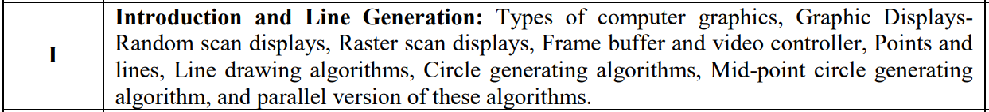

1. Types of computer graphics {Least or Never Asked}
   1. Passive computer graphics
   2. Interactive computer graphics – Advantages and Disadvantages
2. Graphic Displays {Sometime come in Exam}
   1. Random scan displays, Raster scan displays, Difference, Advantages {Sometime come in Exam}
   2. Interlacing {Least or Never Asked}
   3. CRT {Sometime come in Exam}
   4. Display Devices – Plasma Panel, LCD, Flat Panel {LCD Sometime come in Exam}
3. Frame Buffer and Video Controller
   1. Terms - Frame Buffer, Video Basics, Pixels, Aspect Ratio, Resolution, Display Processor
   2. Numerical on Resolution and Frame Buffer {From this section, mostly numerical come}
      1. Refresh rate =

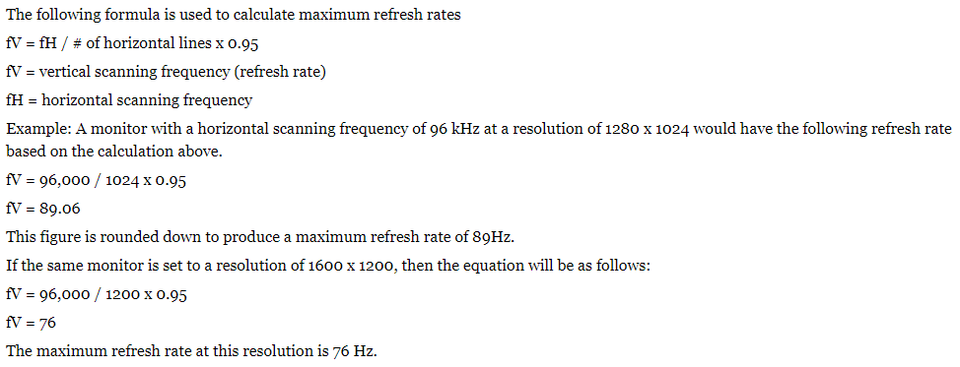

* + 1. Resolution = Number of column (width) * Number of rows (height)
    2. Frame buffer size = (Number of pixel OR resolution * bits per pixel) / 8 bytes

1. Points and lines {Least or Never Asked}
   1. Intercept form of the line

$$y =\left(\frac{y_{2}-y_{1}}{x_{2}-x_{1}}\right)\left(x-x_{1}\right)+ y_{1}$$

OR, $y =m\left(x-x_{1}\right)+ y_{1}$

1. Line drawing algorithms {Most Important}
   1. Digital Differential Analyzer (DDA) Algorithm + Numerical

$$x_{k+1}= \frac{1}{m}+ x_{k}$$

$$y_{k+1}= m+ y_{k}$$

{For algorithm, refer book}

* 1. Bresenham’s line algorithm + Numerical

$$d_{1}=y-y_{i}=m \left(x_{i}+1\right)+ b- y_{i}$$

$$d_{2}=y_{i+1}- y= y_{i+1}- m \left(x_{i}+1\right)+ b$$

$$d_{1}- d_{2}=2 m \left(x_{i}+1\right)- {2y}_{i}+ 2b-1$$

$$p_{i}=∆x (d_{1}- d_{2})$$

{For algorithm, refer book}

* 1. Difference of both algorithm

1. Circle generating algorithms, Mid-point circle generating algorithm, and parallel version of these algorithms
   1. Mid-point Circle Algorithm + Numerical {Most Important}

Link - [Click here to get Algorithm](https://www.javatpoint.com/computer-graphics-midpoint-circle-algorithm)

{For algorithm, refer book}

* 1. Parallel version of line algorithm {Sometime ask in exams, you can refer quantum for this, Ask me, I’ll send photo. There is only one question of this.}
     1. Bresenham’s line algorithm
     2. Raster Scan System